How Can I Help?
(Or, the Africa Connect Checklist, 2019)
Level 1: Doesn’t demand much time, commitment and/or skill (but very effective):
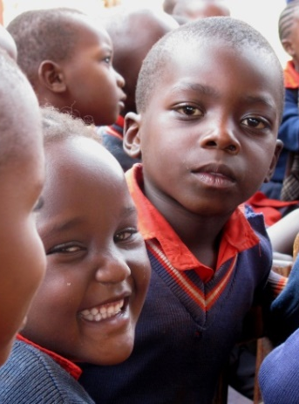
- Stay informed and pray faithfully for the work of AC
- Follow us on Facebook, comment and share posts
- Donate $, encourage others to support
- Help us to advertise, or assist with a project or event
- Sponsor a child through Ian Memorial Sponsorship Fund
- Host a Jewelry/craft party
- Host a house concert
- Initiate/Host a bake sale or tag sale to benefit Africa Connect
Level 2: Join the Team! (more commitment, and more joy!):
- Help to design/create posters, flyers, presentation boards
- Create slideshows/powerpoints
- Write copy; write blogs
- Assist with managing email lists, photos, other assets
- Learn how to set up a table/run a sales event (craft booth, home party)
- Promote online PR (Facebook, Twitter, etc)
- Update the website and/or Manage the Facebook page
- Create/run an Etsy store or Facebook store
Level 3: Be an Ambassador! (start at the shallow end, or just dive in!):
- Travel to Kenya with the team
- Speak as a representative to your church, schools, or community groups
- Present the AC vision at a Home Party or other event
Please check your potential area(s) of interest, fill out the form below and give to an AC representative or mail to Africa Connect, PO Box 598, Lee, MA 01238, or send to: africaconnect.us@gmail.com.
My Name: _____________________________________ Contact preference: __________
Email address: _______________________________ Phone Number: _______________
Mailing address: ___________________________________________________________
How do you know about Africa Connect? ________________________________________

